**Applied Physics**

**Python Project**

1. Write a function **Vector ()** such that it accept a vector A = Axi + Ay j + Azk and return the angles between the vector and the x, y, and z axes, respectively ( α, β, γ) and the magnitude of vector A.
2. Write a function **Damped Oscillation ()** such that it can accept four variables (amplitude , angular frequency , phase constant , time, b ) and return displacement in a single call. The displacement is

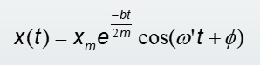

1. Function will also return the type of damped oscillation such as Under Damped (b<2mwo) , Critical Damped (b=2mwo) and Over Dapmed (b>2mwo). Also plot the graph of displacement with respect of time (set time according to your choice).

**Do the following problem in Python coding.**

1. The position vector of a particle is given by

x = 3Sin(t) – 2Cos(t)+ 5t3 ,

where “x” is in meter and “t” is in second. Find an expression for the velocity(v) and acceleration(a) as a function of time. Also plot the graph t verse x , v, and a on same graph.

1. A displacement vector in the xy plane is 7.3 m long and directed at angle of 30° in Fig.1. Determine (a) the x component and (b) the y component of the vector.

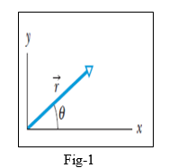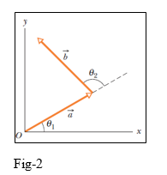

1. The two vectors a and b in Fig-2 have equal magnitudes of 10m and the angles are θ1= 30⁰ and θ1= 105⁰. Find the (a) x and y components of their vector sum r (b) the magnitude of r and (c) the angle r makes with the positive direction of the x axis.
2. Three vectors ***a , b*** and ***c*** each have a magnitude of 50 m and lie in an xy plane. Their directions relative to the positive direction of the x axis are 30°, 195°, and 315°, respectively. What are (i) the magnitude and the angle of the vector ***a+b+c***, and (ii) the magnitude and the angle of ***a-b+c***? What are the (iii) magnitude and angle of a fourth vector ***d*** such that ***(a+b ) – (c+d) = 0***
3. Find the angle between the vector A= 2i -3j+5k and the x, y, and z axes, respectively.